

**Semester One Examination 2017**

**Question/Answer Booklet**

**MATHEMATICS SPECIALIST**

**UNIT 1**

**Section One:**

**Calculator-free**

| Student Name: _____________________________________ |
| --- |
| Teacher‘s Name: _____________________________________ |
|  |

**Time allowed for this section**

Reading time before commencing work: five minutes

Working time for paper: fifty minutes

**Material required/recommended for this section**

**To be provided by the supervisor**

This Question/Answer booklet

Formula Sheet

**To be provided by the candidate**

Standard items:pens(blue/black preferred), pencils(including coloured), sharpener, correction tape/fluid, erasers, ruler, highlighters

Special Items: nil

**Important note to candidates**

No other items may be taken into the examination room. It is **your** responsibility to ensure that you do not have any unauthorised notes or other items of a non-personal nature in the examination room. If you have any unauthorised material with you, hand it to the supervisor **before** reading any further.

**Structure of this paper**

|  | Number of questions available | Number of questions to be attempted | Suggested working time (minutes) | Marks available |
| --- | --- | --- | --- | --- |
| **Section One**  **Calculator—free** | **7** | **7** | **50 minutes** | **50** |
| Section Two  Calculator—assumed | 12 | 12 | 100 minutes | 100 |
|  | | | | 150 |

**Instructions to candidates**

1. The rules for the conduct of Western Australian external examinations are detailed in the *Year 12 Information Handbook 2017.* Sitting this examination implies that you agree to abide by these rules.
2. Answer the questions according to the following instructions.

Section One: Write answers in this Question/Answer Booklet. Answer **all** questions.

**Show all your working clearly.** Your working should be in sufficient detail to allow your

answers to be checked readily and for marks to be awarded for reasoning. Incorrect

answers given without supporting reasoning cannot be allocated any marks. For any

question or part question worth more than two marks, valid working or justification is

required to receive full marks. If you repeat an answer to any question, ensure that you

cancel the answer you do not wish to have marked.

It is recommended that you **do not use pencil**, except in diagrams.

1. You must be careful to confine your responses to the specific questions asked and to follow any instructions that are specific to a particular question.
2. Spare pages are included at the end of this booklet. They can be used for planning your responses and/or as additional space if required to continue an answer.

* Planning: If you use the spare pages for planning, indicate this clearly at the top of the

page.

* Continuing an answer: If you need to use the space to continue an answer, indicate in the original answer space where the answer is continued, i.e. give the page number. Fill in the number of the question that you are continuing to answer at the top of the page.

1. The Formula Sheet is **not** handed in with your Question/Answer Booklet.

# Section One: Calculator–free 50 marks

This section has **seven (7)** questions. Attempt **all** questions. Write your answers in the spaces provided.

Working time: 50 minutes

**Question 1 (6 marks)**

(a) Determine vector in terms of vectors and for each diagram below. (3 marks)

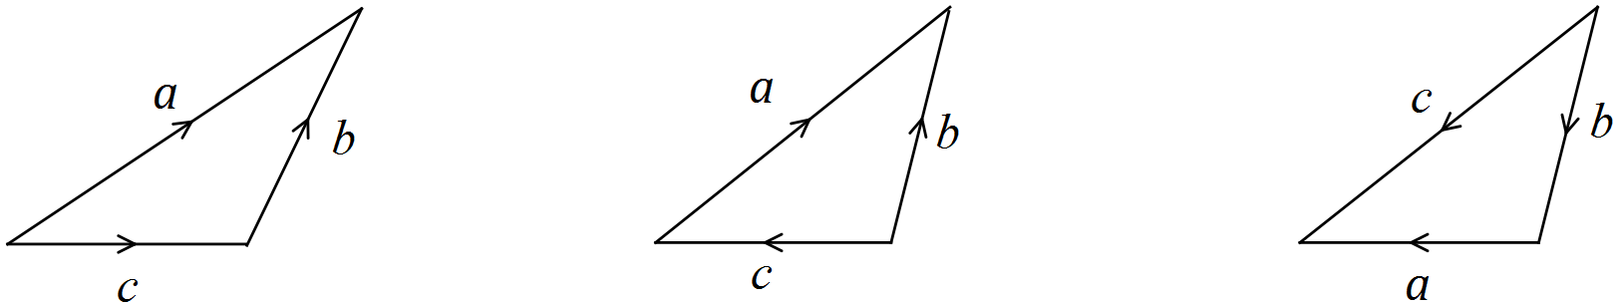

(b) Draw a vector diagram containing vectors such that (1 mark)

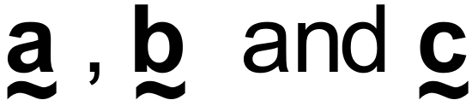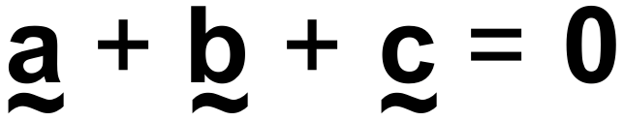

(c) Given that , circle the correct statement(s) from the list below. (2 marks)

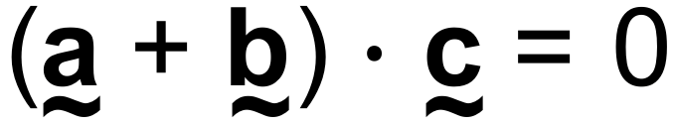

Neither nor = **0.**



I is perpendicular to



II is perpendicular to



III neither nor is perpendicular to



IV is perpendicular to

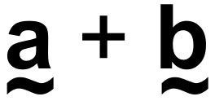

**Question 2 (8 marks)**

There are 50 houses on Venn Street, and they are all occupied. 30 of these houses are occupied by married couples, of which 20 have children, 14 have pets and 6 have neither children nor pets.

(a) Show how to use the inclusion-exclusion principle for two-sets to determine the number of houses on Venn St that contain married couples that have both children and pets. (3 marks)

It is also known that 27 houses have children living in them, 27 houses have pets, and 5 houses are occupied by single individuals with no children and no pets.

(b) Show how to use the inclusion-exclusion principle for three-sets to determine the number of houses on Venn St that have both children and pets. (3 marks)

(c) What is the minimum number of houses that must be chosen to ensure that there is at least one house that contains a married couple with both children and pets?

State the name of the principle used to determine the answer. (2 marks)

**Question 3 (5 marks)**

The angle between and is , with and .

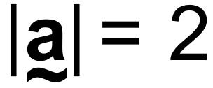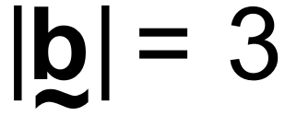

(a) Draw a clearly labelled sketch of the vectors , , including the location of



(2 marks)

(b) Given that , determine the value of . (3 marks)

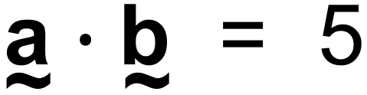

**Question 4 (13 marks)**

Consider the portion of Pascal’s triangle shown below.

|  | |  | |  |  | |  |  | 1 | | 2 | | 1 | |  |  | |  |  | |  |  | |
| --- | --- | --- | --- | --- | --- | --- | --- | --- | --- | --- | --- | --- | --- | --- | --- | --- | --- | --- | --- | --- | --- | --- | --- |
|  | |  | |  |  | |  | 1 | | 3 | | 3 | | 1 | |  | |  |  | |  |  | |
|  | |  | |  |  | | 1 | | 4 | | 6 | | 4 | | 1 | | |  |  | |  |  | |
|  | |  | |  | 1 | | | 5 | | 10 | | 10 | | 5 | | 1 | | |  | |  |  | |
|  | |  | | 1 | | | 6 | | 15 | | 20 | | 15 | | 6 | | | 1 | | |  |  | |
|  | | 1 | | | 7 | | | 21 | | 35 | | 35 | | 21 | | 7 | | | 1 | | |  | |
|  | 1 | | 8 | | | 28 | | | 56 | | 70 | | 56 | | 28 | | 8 | | | 1 | | |  |

(a) Evaluate.

(i) (1 mark)

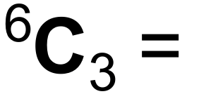

(ii) (1 mark)

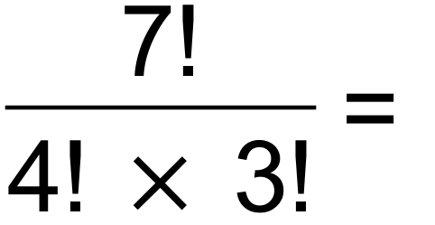

(b) State the value of *x* in each case below.

(i) (1 mark)

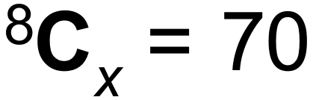

(ii) (1 mark)

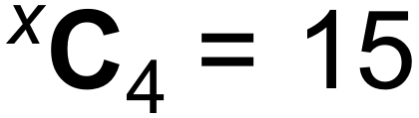

(iii) (1 mark)

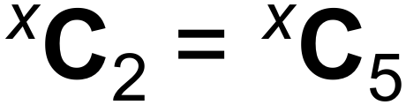

(iv) (1 mark)

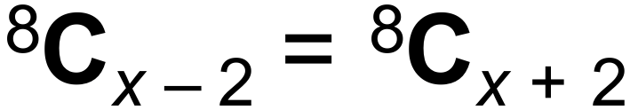

**Question 4 (Continued)**

(c) An academic team of 5 members is to be composed from 3 mathematicians, 3 physicists

and 2 chemists.

(i) How many different teams of 5 academics can be assembled if there are no other restrictions? (1 mark)

(ii) How many different teams of 5 academics can be assembled if it must contain at

least 2 mathematicians? (3 marks)

(d) The 5 academics from (c) line up for a team photo.

How many different arrangements are possible if:

(i) no other restrictions apply? (1 mark)

(ii) the team has two mathematicians, and they must not stand next to each other? (2 marks)

**Question 5 (6 marks)**

(a) If and , then determine . (4 marks)

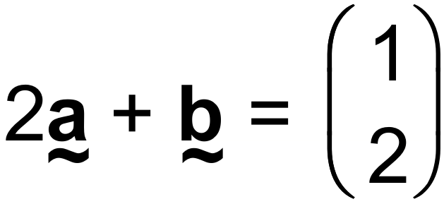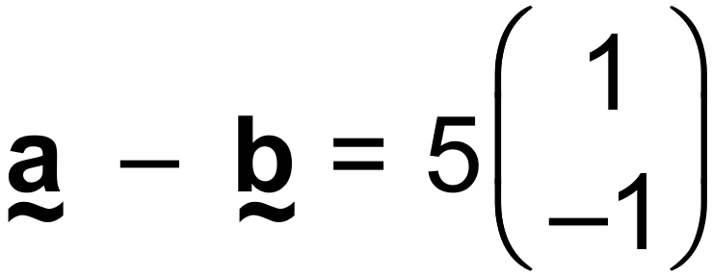

(b) Obtain a unit vector normal to 2***i*** – 3***j***. (2 marks)

**Question 6 (7 marks)**

In the diagrams below, as shown.

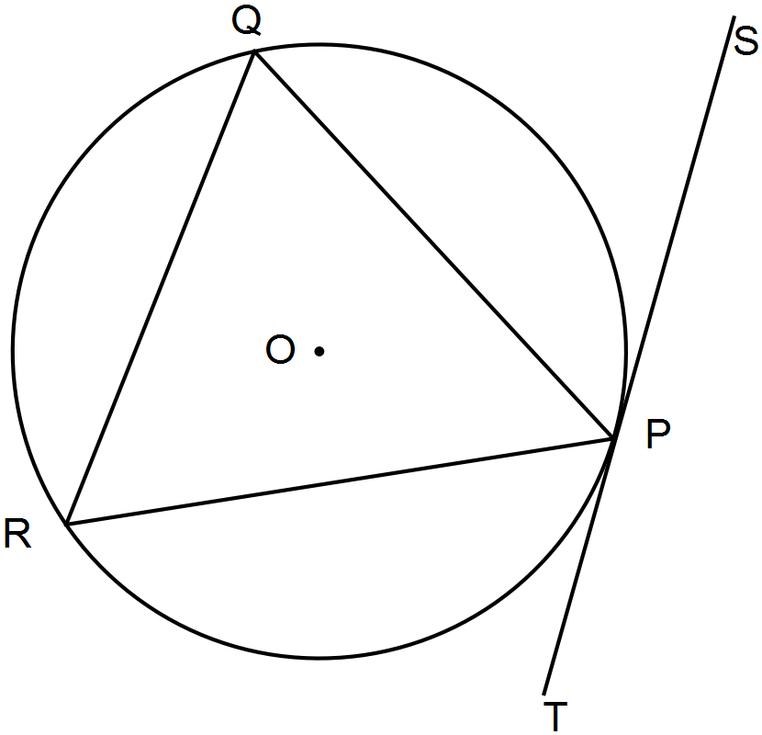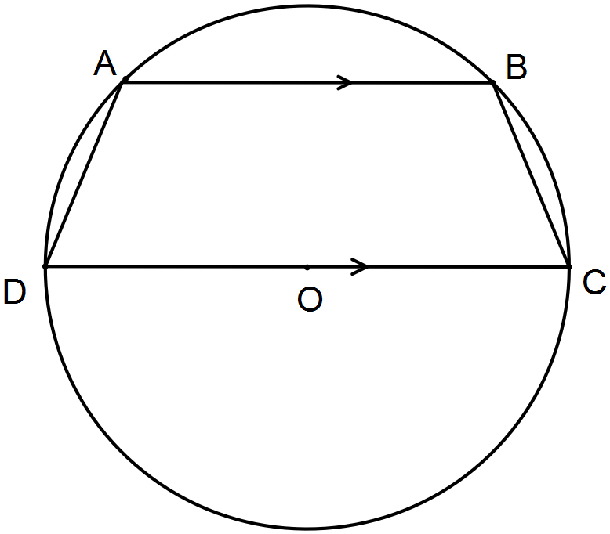

(a) Determine the size of (3 marks)



(b) Determine the size of providing reasons for your answer. (2 marks)



(c) Determine the size of and state the name of the theorem used. (2 marks)

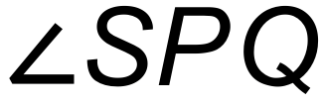

**Question 7 (5 marks)**

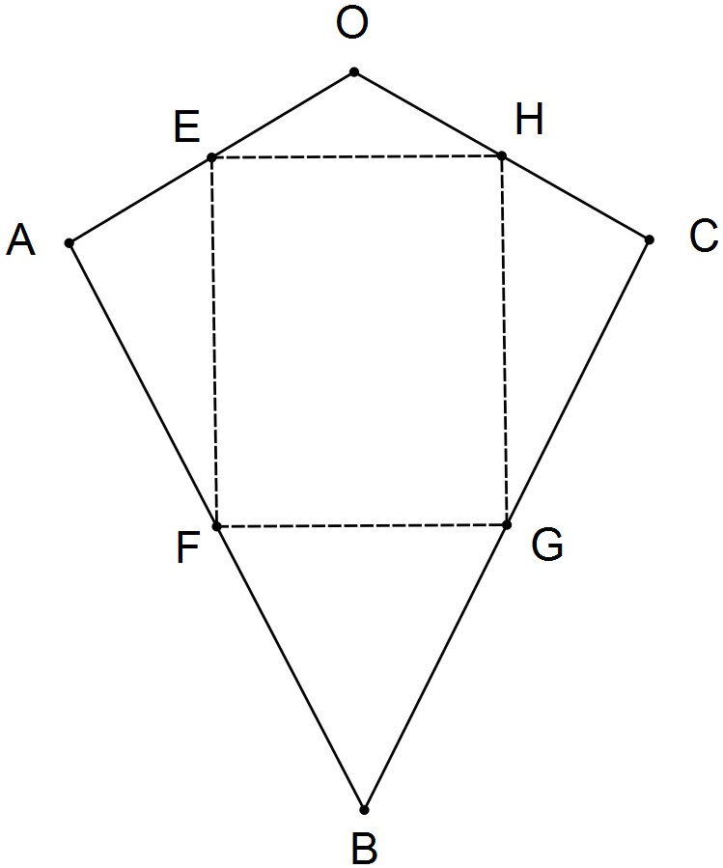

Quadrilateral OABC shown has F, G, H and E as midpoints

of AB, BC, CO and OA respectively.

Let , and

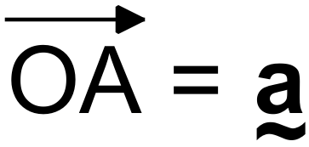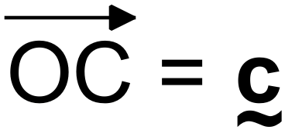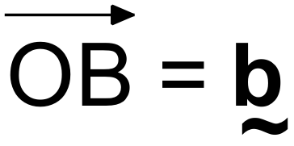

(a) Determine in terms of , . (2 marks)

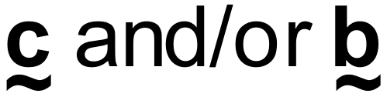

(b) Prove that quadrilateral FGHE is a parallelogram. (3 marks)

**End of Section One**

**Additional working space**

Question number(s): ……………………

**Additional working space**

Question number(s): ……………………

WATP acknowledges the permission of School Curriculum and Assessment Authority in

providing instructions to students.